Use this form to assist you to complete risk assessments for hazardous activities and processes. Any serious or ongoing hazards should be reported via RiskWare to ensure that appropriate corrective actions are tracked and completed.

Faculty/School: | Faculty of Science — School of Physics (SAIL Labs) | Initial Issue Date: 2020-06-17
Faculty/School: | Faculty of Science — School of Physics (SAIL Labs) | Next Review Date: 2027-07-16
Risk Assessment Reference Number: | RA-A28-SAIL-116C-formlabs-form3
Risk Assessment Name: | Operation Maintenance Of Formlabs Form 3 SLA 3D Printer
Prepared by: | Chris Betters, Justin Digweed
Responsible supervisor/s: | Chris Betters, Sergio Leon-Saval

Identify the activity and the location | Identify who may be at risk  This might include fellow workers, students, visitors, contractors, patients, research participants and the public
Activity or process:  The Form 3 is a commercial, precision tool intended for use in the additive manufacture of  end-user supplied designs from photopolymer resin. The final performance characteristics of  cured photopolymer resin may vary according to compliance with the instructions for use,  application, operating conditions, material combined with, end use, or other factors.  This RA/SWP covers operation of the SAIL Form 3, including:  - Print preparation (file preparation in PreForm, resin cartridge and tank installation)  - Printing  - Finishing - washing printed parts in isopropyl alcohol (IPA), drying and curing  - Cleanup and waste disposal  - Routine user maintenance and inspection  TODO: The source document is titled Formlabs 3 but the operating and maintenance text throughout  refers to the Form 3B (the biocompatible variant). Confirm which model is installed in A28-116C  and make the model designation consistent before approval. | Persons at risk:  All staff and students of SAIL that use the Form 3, Contractors and others in the vicinity
Location:  Room A28-116C, Physics Building A28 | Risk assessment team (who was consulted?):  Physics WHS Committee, SAIL Staff, RPF Staff

List of Legislation, Code of Practice, Australian Standards, Guidance Materials used to determine control measures
Work Health and Safety Act 2011 (NSW)
Work Health and Safety Regulation 2017 (NSW)
Formlabs Form 3 Quick Start Guide (support.formlabs.com/s/article/Quick-Start-Guide-Form3)
Formlabs Form 3 Manual (media.formlabs.com/m/5a3f3cadc639b857/original/-ENUS-Form-3-Manual.pdf)
Safety Data Sheet - Formlabs Clear V4.1 Resin (media.formlabs.com/m/6552f8debd66e922/original/-ENAU-Safety-Data-Sheet-Clear-V4-1-Resin.pdf)
Safety Data Sheet - Formlabs Black V4.1 Resin (media.formlabs.com/m/75811facbde95dad/original/-ENAU-Safety-Data-Sheet-Black-V4-1-Resin.pdf)
Formlabs resin technical specifications and data sheets (formlabs.com/3d-printers/resin/tech-specs/#data-sheets)
SAIL-RA-SWP-02 - Use, storage and disposal of flammable liquids
ChemAlert report - isopropyl alcohol (chemalert.rmt.com.au/syduni/rest/reports/available-report/8447fba0-f957-4eab-a7c5-014e9e5c51b2)
ChemSupply isopropyl alcohol SDS (shop.chemsupply.com.au/documents/PA0131CH5R.pdf)
CHEMICALS INVOLVED:
- UV curable resins - MUST NOT come into contact with the skin. Respect Formlabs resin like any
household chemical. Follow standard chemical safety procedures and Formlabs resin handling
instructions. Formlabs resin is NOT approved for use with food, drink, or medical applications
on the human body. Refer to the SDS for each specific resin for more detail.
- IPA is used in the cleaning process. Formlabs does not manufacture IPA - consult the chemical
manufacturer or supplier for detailed safety information and carefully follow the safety
instructions provided with the IPA purchased. IPA is HIGHLY FLAMMABLE, even explosive, and MUST
be kept away from heat, fire, or sparks. Any containers holding IPA MUST be kept closed or
covered when not in use. Wear protective gloves and ensure good ventilation when working with IPA.

Risk Assessment Methodology

Assessing the risk is a brainstorming exercise, which is most effectively carried out in a team environment with the people required to complete the activity or process. Most activities or processes are broken down into a variety of separate tasks. For each task, consider the hazards, the potential harm or negative outcomes and the conditions required for those negative outcomes to occur.

Whenever assessing the health and safety risks associated with a task, always consider the following primary risk factors.
- The physical activities required to complete the task e.g. repetitive movement, high force, physical exertion, awkward posture
- The work environment e.g. lighting, layout, traffic flow, ventilation, access to support (isolation)
- The nature of the hazard itself e.g. working with chemicals, microorganisms, radiation, use of plant and equipment, sharps, working with potentially aggressive clients, patients or research participants
- The people involved, e.g. level of training, supervision, experience, health, age, physical capacity.
The information gathered from the risk assessment process must be used to develop a Safe Work Procedure (SWP) or clinical protocol for the activity.

Task or scenario | Hazard/s | Associated harm, e.g. what could go wrong? | Existing Risk Controls | Current risk rating  Use the Risk Matrix | Any additional controls are required? | Residual risk rating  Use the Risk Matrix
General usage | Hot surfaces within the system cabinet | - Burns to hands or arms from contact with heated surfaces inside the cabinet  TODO: The Associated harm column was blank in the source document for every risk row. The harm  described here is inferred from the hazard and MUST be confirmed by the assessment team. | Engineering: Hot surfaces are present within the system cabinet. NEVER reach inside the unit  while it is in operation or in its cooling down phase.  PPE: Protective gloves and safety glasses MUST be worn when working with the Form 3 printer. | Low | None | Low
General usage | Moving parts | - Crushing, pinching or entanglement injuries to fingers and hands from the build platform,  lead screws and light processing unit  TODO: Harm inferred - the source document left this column blank. Confirm with the assessment team. | Engineering: NEVER reach inside the unit when the system is in operation.  Administrative: There is an interlock system in place. | Medium | None | Low
Unloading part, swapping materials | Chemical contact with uncured Formlabs photopolymer resin | - Skin irritation and sensitisation from contact with uncured resin  - Eye irritation from splashes  TODO: Harm inferred - the source document left this column blank. Confirm against the SDS for each  resin in use and with the assessment team. | Administrative: Personnel are made aware through signage that gloves MUST be worn at all times  whilst using any Formlabs process. Refer to the SDS for the resin in use before handling.  PPE: Safety glasses and gloves MUST be worn at all times during this process. | Low | None | Low
Cleaning parts | Chemical contact with isopropyl alcohol (IPA) and uncured resin residue | - Skin defatting, drying and irritation from IPA contact  - Eye irritation from splashes  - Inhalation of IPA vapour if used outside the fume hood  TODO: Harm inferred - the source document left this column blank. Confirm against the IPA SDS and  with the assessment team. | Engineering: The cleaning process involves washing printed parts in a bath of isopropyl alcohol  (IPA). This MUST only be done inside a fume hood.  Administrative: The cleaning process is automated but MUST NOT be performed outside of the fume  cabinet. Keep IPA containers closed or covered when not in use.  PPE: Safety glasses and gloves MUST be worn at all times during this process. | Low | None | Low

Implementation of Additional Risk Controls

Additional controls needed | Resources required | Responsible person | Date of implementation | RiskWare Reference
Write the Safe Work Procedure (SWP) or clinical protocol for the relevant activity | Time (approx 1 hour) | Supervisor | 2026-07-16 | N/A
Education and training for workers to complete process in accordance with SWP | Time – supervisor and workers | Supervisor | 2026-07-16 | N/A
TODO: The source document identifies IPA as highly flammable, even explosive in its reference  notes, but contains NO risk row assessing fire or ignition of IPA vapour. Add a fire/flammability  risk row (task, hazard, harm, controls, ratings) or record why SAIL-RA-SWP-02 (flammable liquids)  is considered to cover it in full. Ratings for any new row MUST be set by the assessment team. | Assessment team time; SAIL-RA-SWP-02; IPA SDS | Chris Betters | Before approval | N/A
TODO: The source document has an empty Clean up and waste disposal requirements section. The  cleanup and waste content in this document is derived from the surrounding text and MUST be  reviewed and completed - confirm the resin waste stream, IPA waste stream, and disposal route for  contaminated gloves, wipes and resin tanks. | Process owner time; USyd chemical waste guidance | Chris Betters | Before approval | N/A
TODO: Confirm the printer model (Form 3 vs Form 3B) and reconcile the document title, operating  steps and maintenance schedule to the correct model. | Equipment engineer time | Chris Betters | Before approval | N/A
TODO: The source document's risk ratings carried likelihood/consequence detail (Unlikely, L2,  Rare, L2, Unlikely, L3) that the current template does not have a field for. Confirm the  four-level ratings recorded here still reflect the assessment team's intent. | Assessment team time; University Risk Matrix | Chris Betters | Before approval | N/A

List emergency controls
These might include how to deal with fires, spills, emergency shutdown of equipment, exposure to hazardous materials and adverse reactions or the deteriorating condition of a patients/research participants in our care.

An emergency stop button is located on the wall in the lab.
In the event of a power outage, leave the building immediately and assemble on the sports oval on Physics Road. If it occurs after hours, call one of the listed Emergency Contacts.
If the evacuation alarm sounds, leave the room immediately and assemble on the sports oval on Physics Road.
For resin or IPA contact with skin or eyes, refer to the SDS for the chemical and apply the first aid measures it specifies. Seek medical attention if irritation persists.
Report all incidents, injuries and near misses via RiskWare.
Emergency services: 000. USyd Security: 9351 3333.

REVIEW

Scheduled review date | 1 year | 2 years | 3 years
Are control measures in place (YES/NO)
Are controls eliminating or minimizing the risk (YES/NO)
Are there any new problems with the risk (YES/NO)
Reviewed by:
Actual Review date:

Risk Matrix.

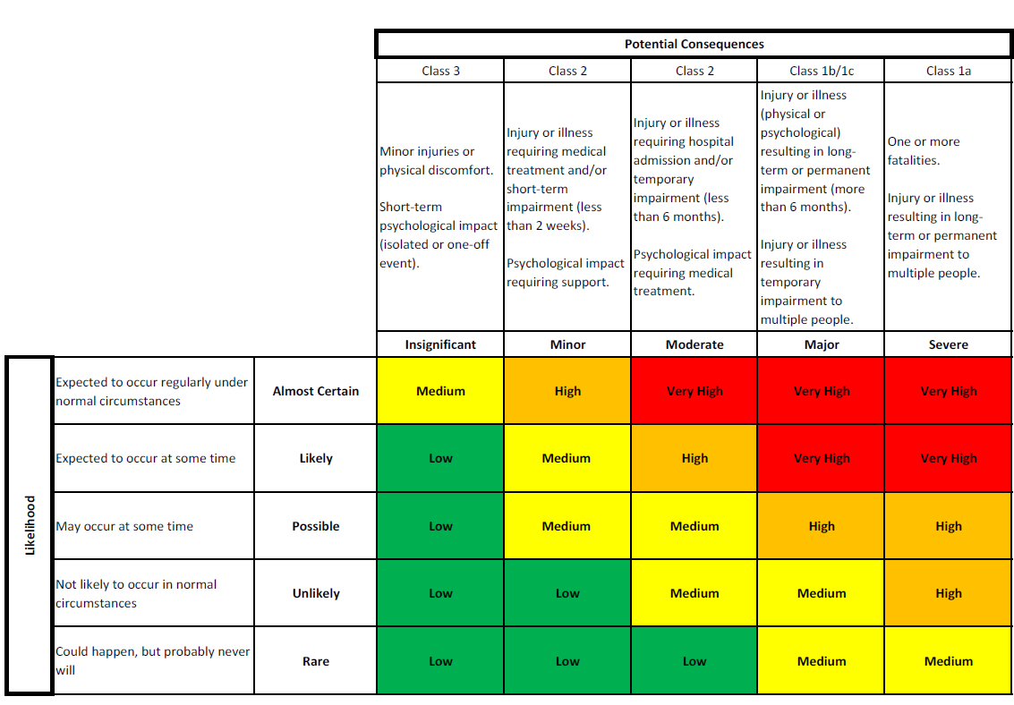

This tool should also be used to assess the risk associated with clinical activities. Information gathered will be used to guide the classification of clinics in accordance with the University’s Health Clinics and Clinical Services Policy and Procedures 2020.
Always consider whether it is possible to eliminate the hazard or hazardous task altogether. If this is not possible, refer to the hierarchy of risk controls.

